Install Python 3 in linux : sudo apt install python3

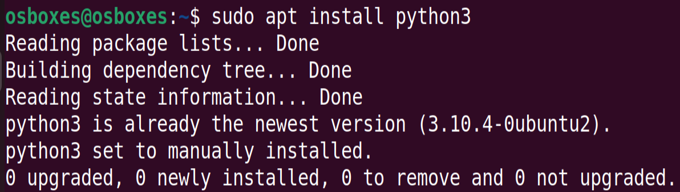

Install MPI Environment: sudo apt install -y -qq mpich

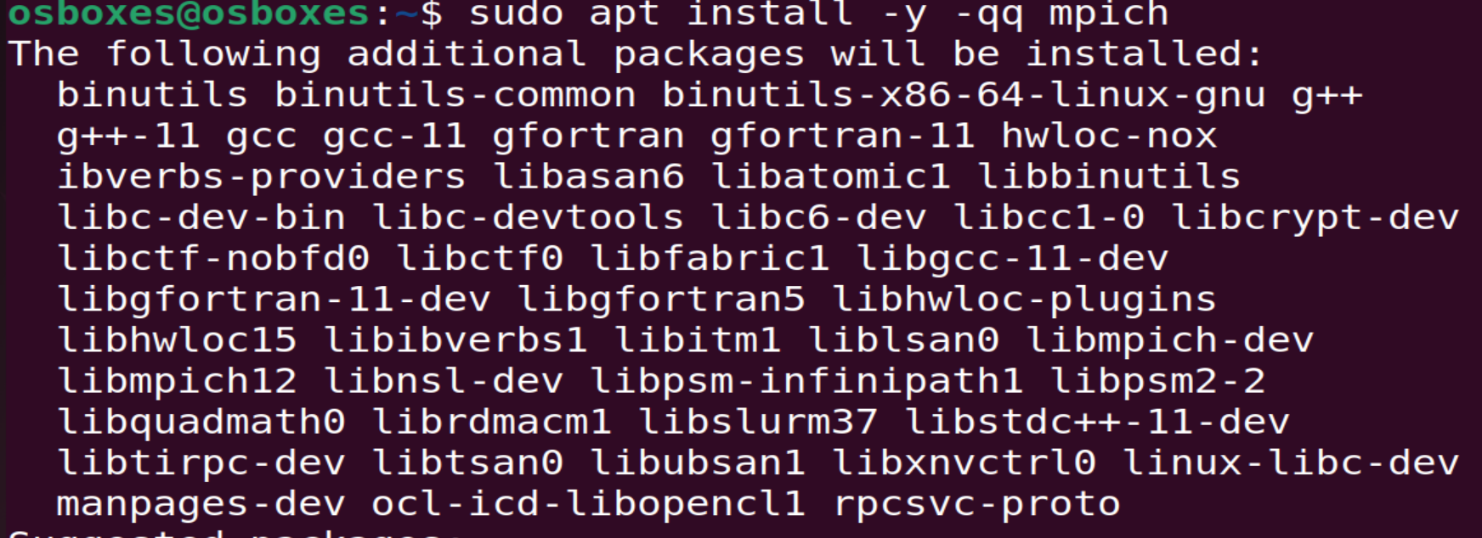

Wait till the installation completes

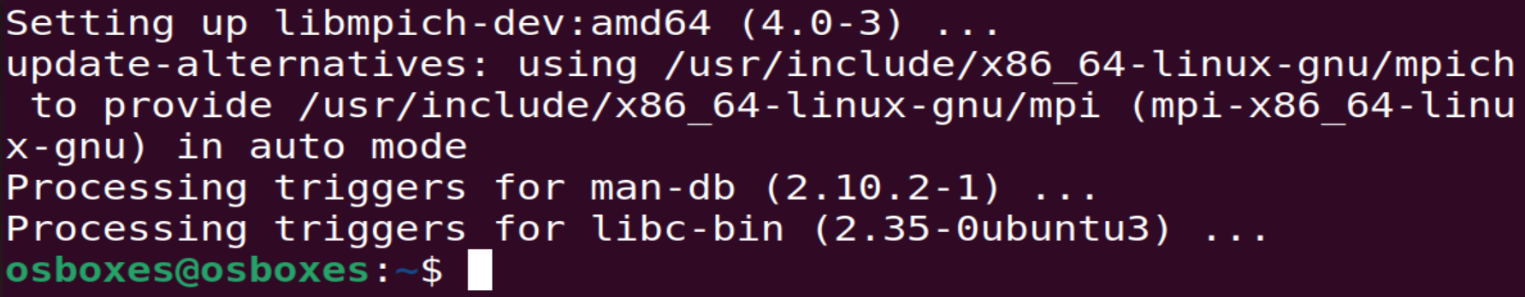

Install pip: sudo apt install python3-pip

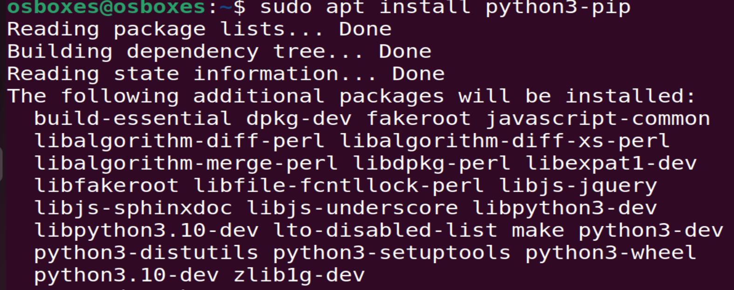

Install mpi4py: pip install mpi4py

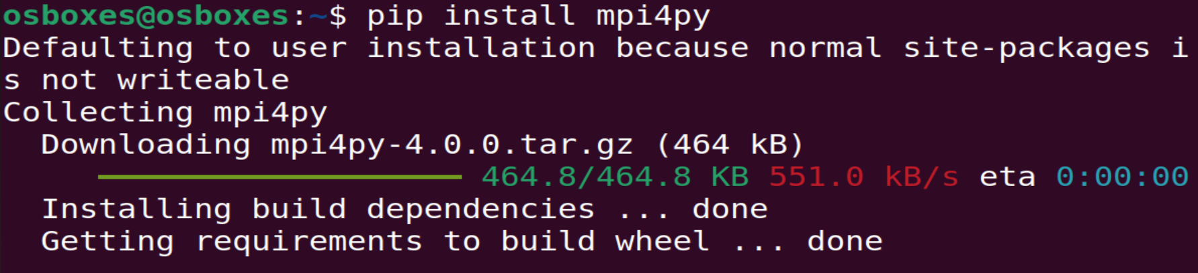

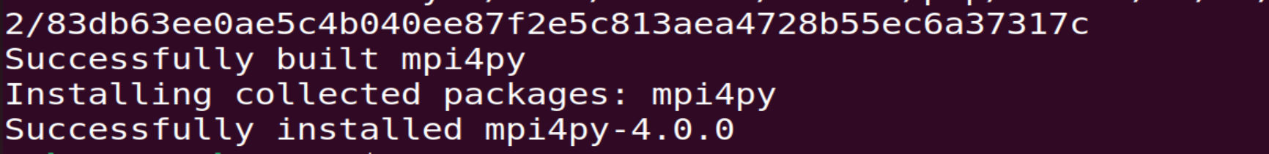

Once the environment is set, Open a editor and write a parallel python script. Eg. mpi_example.py



Sample Parallel Program

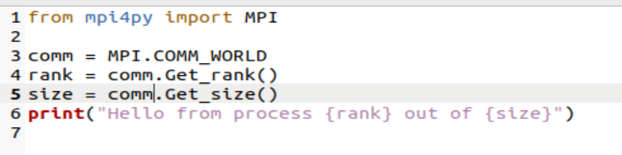

Save the script and Run : mpirun -np 4 python3 mpi_example.py

